**Cloud Based e-book Delivery Solution**

The Requirements:

1. Cloud solution that captures Email and Username from the customer.
2. Host a website with a subscription form that asks visitors to sign up. In return, provide a gut-friendly recipe book. The email will be used for future marketing campaigns.
3. Ensure the e-book is only available to genuine signups.
4. Solution without any manual administration and management on servers.

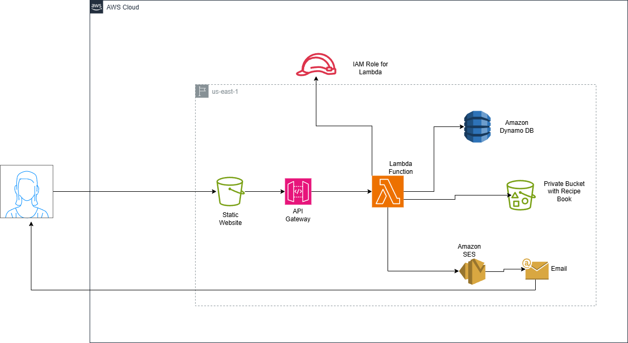

Frontend Website & Recipe Book Storage: **Static website and Book Repository**

Compute services & Business Logic: **Lambda Function**

Database: **Dynamo DB**

**Steps**

1. Create amazon S3 Bucket for recipe Book
   1. Add book/book.pdf into s3 bucket.
2. Create Dynamo DB table
3. Configure SES
   1. Create identity with email address

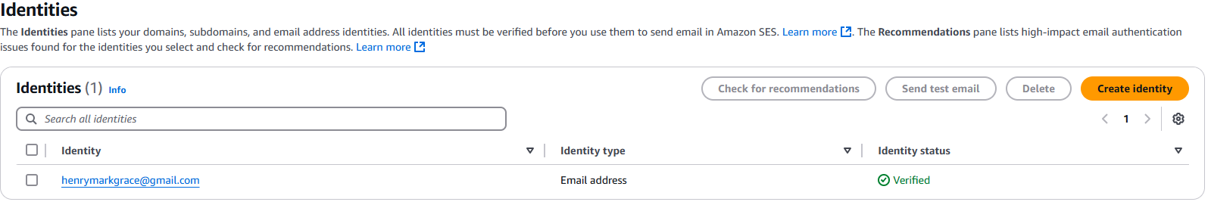

1. Define IAM Policy and IAM Role for AWS Lambda
   1. Create Policy
   2. Create a Role for Lambda service. Attach the role to the policy created.
2. Create Lambda Function and Integrate the Role
   1. Paste the code. Set the environment variables

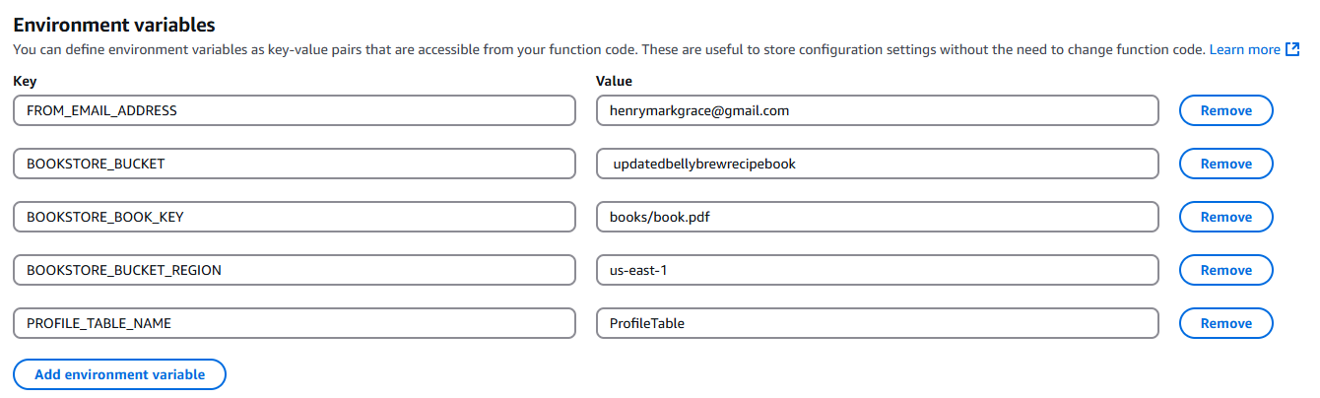

1. Build HTTP API with API Gateway (when user clicked submit button)
   1. We build http api. Take note of the invoke url

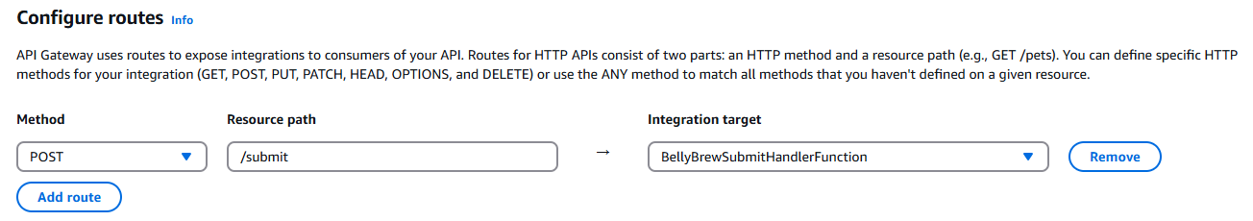

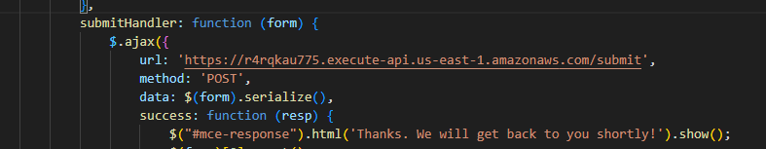

1. Create Amazon S3 Static Website Hosting
   1. Upload the main files into the bucket
   2. Even though we set it publicly accessible, we need to provide correct permissions.

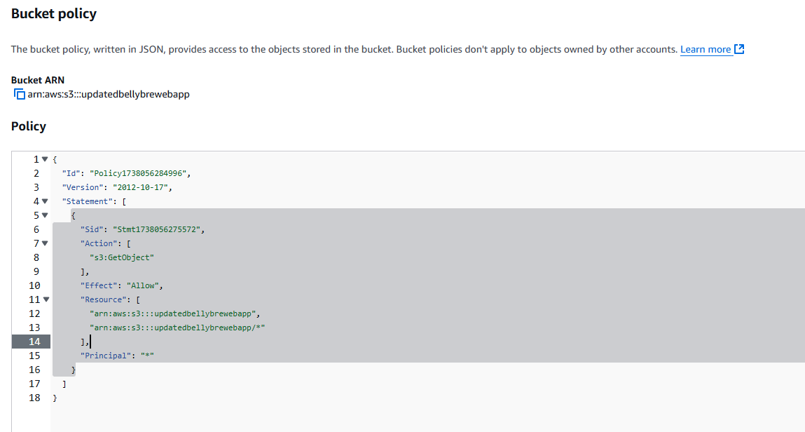

We used a policy generator in this case.

* 1. Set this website as a static website hosting service.

1. Test Application

